NATIONAL UNIVERSITY OF MODERN LANGUAGE ISLAMABAD
Lab 07


Submitted to:
Ms. Fatima Gillani
Submitted by:
Zulqarnain Hassan
Roll No: …………………… SP21379
Subject: …………………… SCD
Department: ……………… BSSE-5-Afternoon
Date: ……………………… 14-11-2024

Lab Task 7: Petrinets
1: Consider a Scenario of Vending Machine for Beverages
Step 1
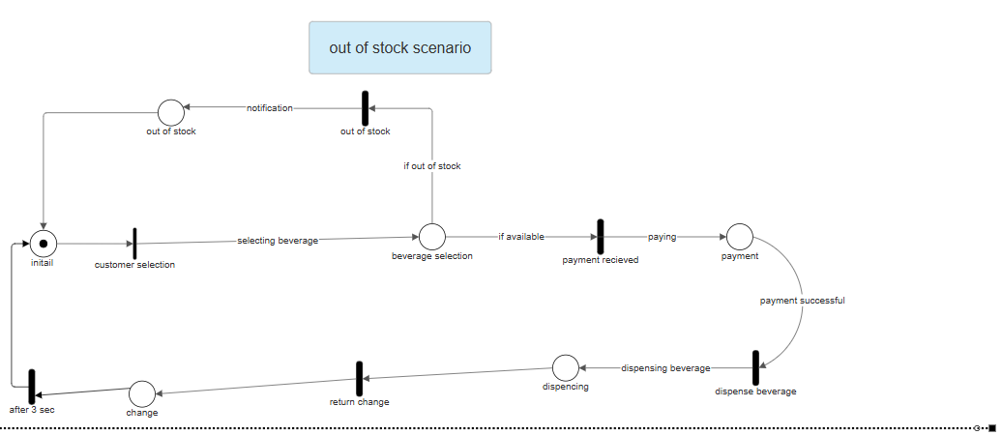

Step 2
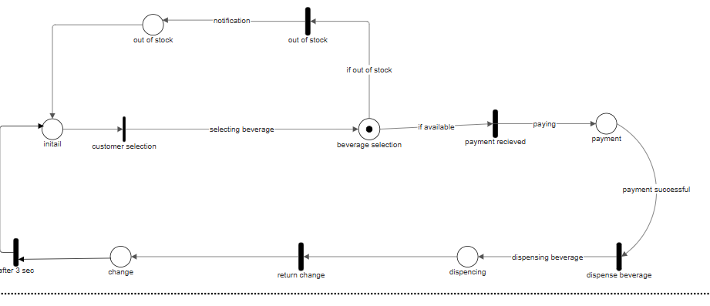

Step 3
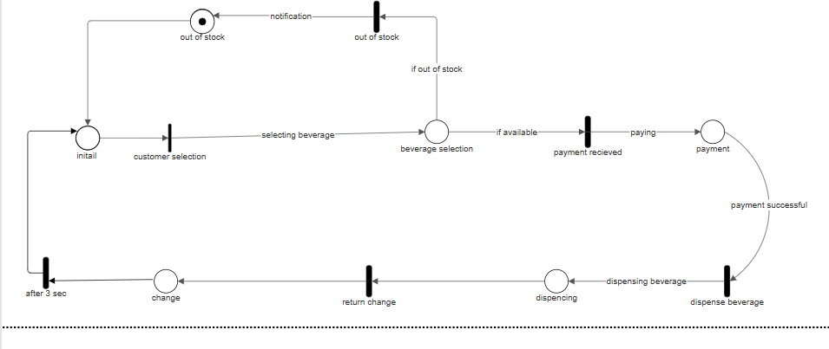

Step 4
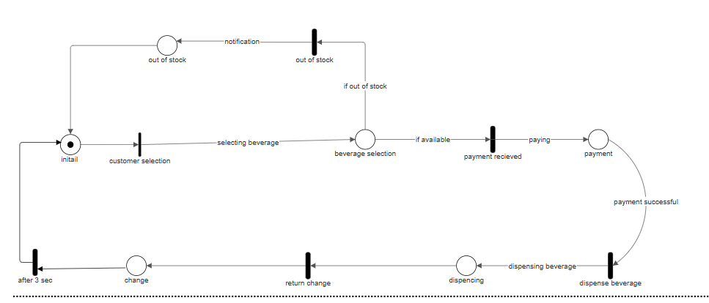

Step 1

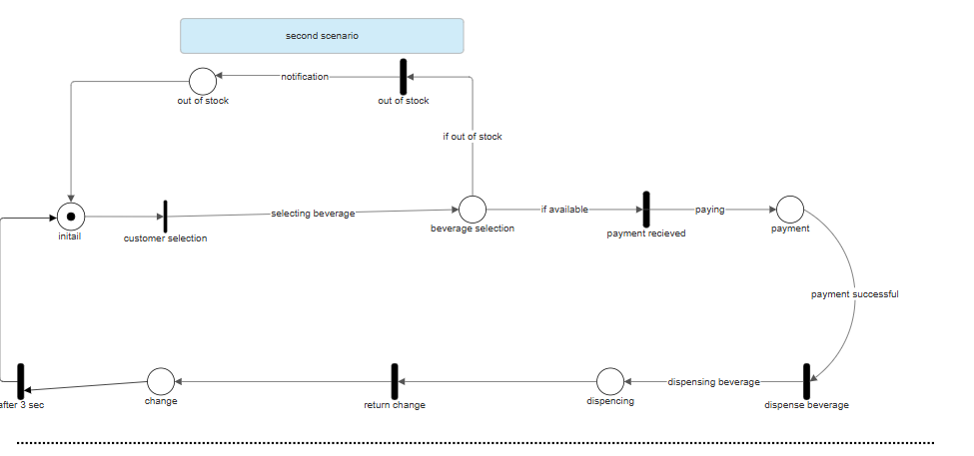

Step 2

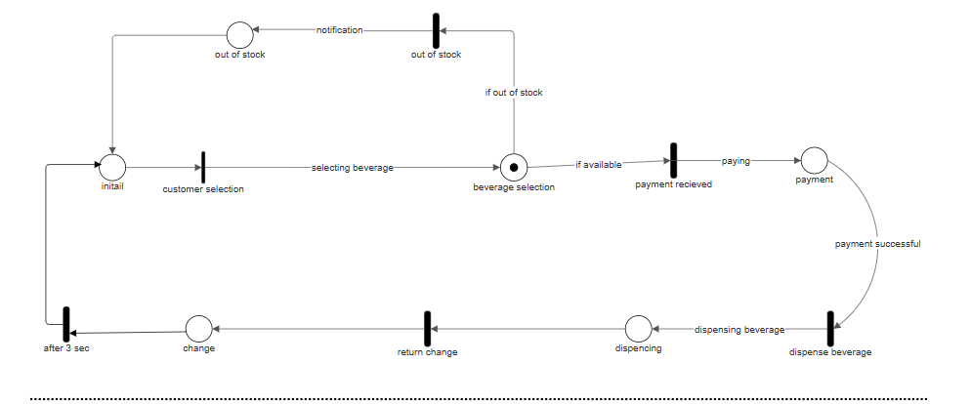

Step 3

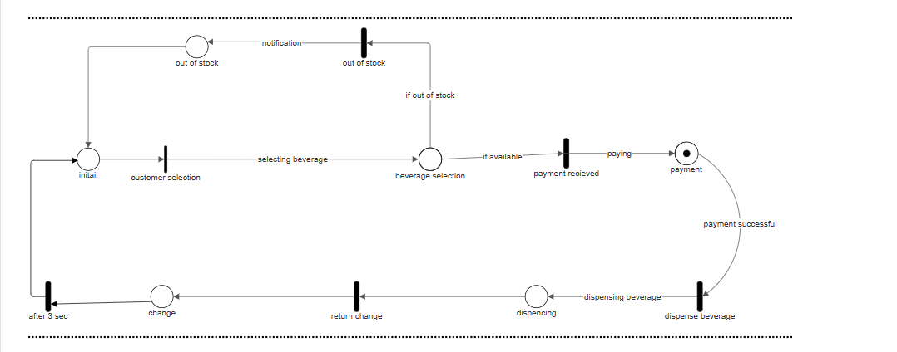

Step 4

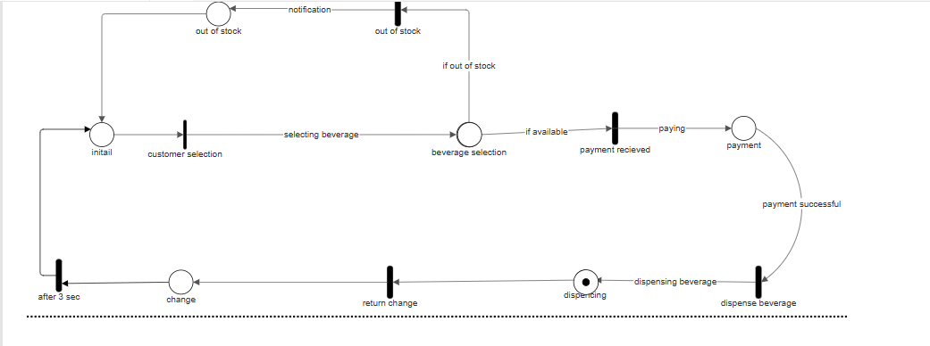

Step 5

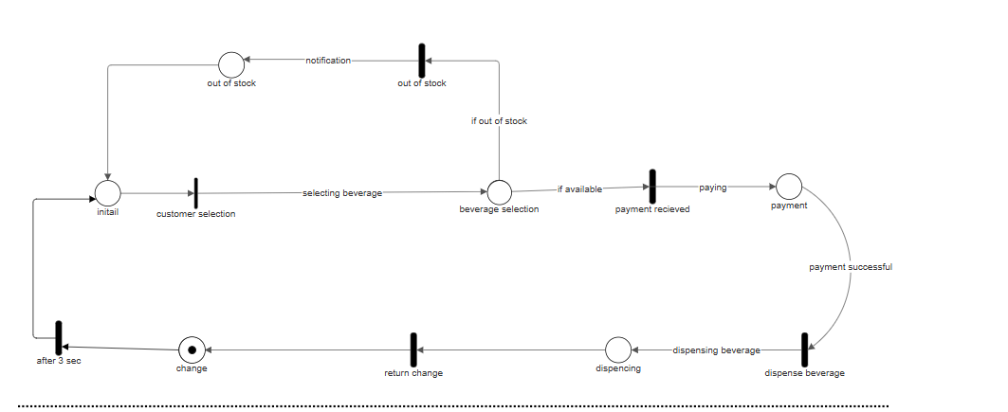

Step 6

